**Develop a menu-driven application that demonstrates the implementation of handling Frames in Selenium.**

**Code:**

|  |
| --- |
| package demowork;  import org.openqa.selenium.By;  import org.openqa.selenium.WebDriver;  import org.openqa.selenium.WebElement;  import org.openqa.selenium.chrome.ChromeDriver;  import org.openqa.selenium.support.ui.Select;  public class Frames {  public static void main(String[] args) throws InterruptedException {  WebDriver driver = new ChromeDriver();  driver.get("https://www.nyrtutorials.com/p/frames-practice.html");  driver.manage().window().maximize();  // Switching to the first frame  driver.switchTo().frame("fr1");  WebElement nameElement = driver.findElement(By.*id*("name"));  nameElement.sendKeys("Supreme Tester123");  Thread.*sleep*(2000);  WebElement courseElement = driver.findElement(By.*id*("course"));  Select courseSelect = new Select(courseElement);  courseSelect.selectByIndex(2);  System.*out*.println("Frame 1");  // Switching back to the main page  driver.switchTo().defaultContent();  // Switching to the second frame  driver.switchTo().frame("fr2");  WebElement raviElement = driver.findElement(By.*id*("selectravi"));  Select raviSelect = new Select(raviElement);  raviSelect.selectByIndex(2);  System.*out*.println("Frame 2");  // Switching back to the main page  driver.switchTo().defaultContent();  // Switching to the third frame  WebElement frame3Element = driver.findElement(By.*id*("fr3"));  driver.switchTo().frame(frame3Element);  WebElement naviElement = driver.findElement(By.*id*("selectnavi"));  Select naviSelect = new Select(naviElement);  naviSelect.selectByIndex(4);  System.*out*.println("Frame 3");  // Switching back to the main page  driver.switchTo().defaultContent();  }  } |

**Output:**

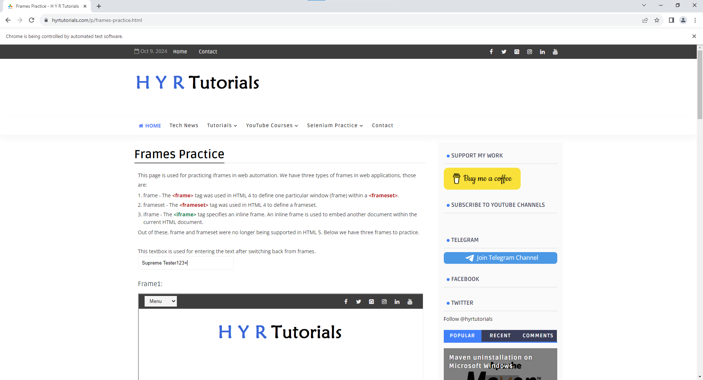

1. **Frame 1:-**

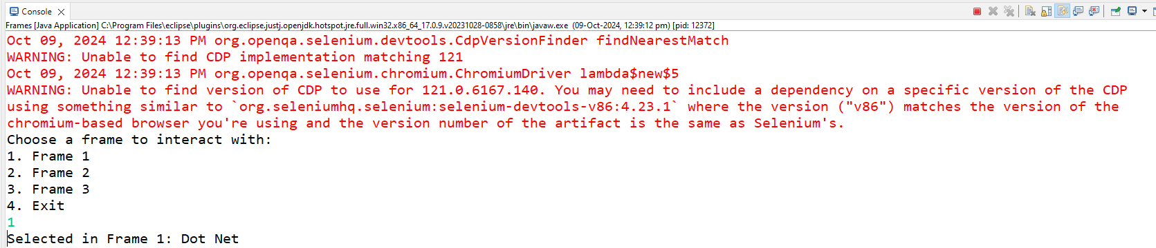

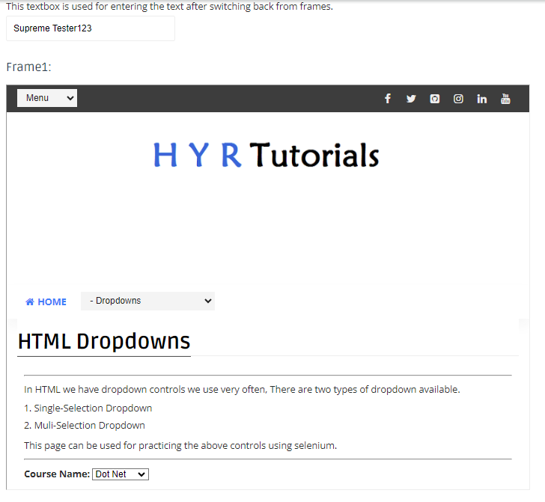

1. **Frame 2:-**

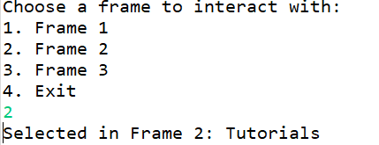

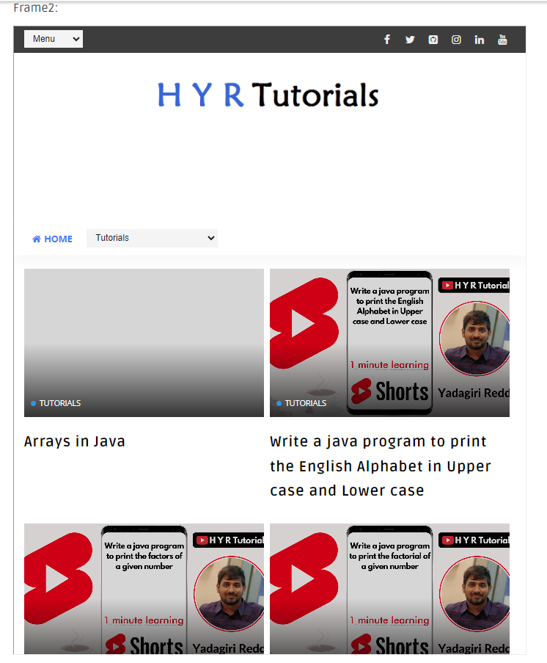

1. **Frame 3:-**

